**Milestone 2**

**Source Squad**

**10/22/2023**

**Table of Contents**

**Meeting minutes (GitHub)…...3**

**Work Breakdown Structure (WBS)** …...5  
**Gantt Chart & Network Diagram …... 6**

**Detailed Requirements Document ….8**

**Fully Dressed-Use Cases…...10**

**Use Case Diagram…...13**

**Research on other systems …... 14**

**API Descriptions …... 15**

**Meeting minutes (GitHub)**

Repository: Source Squad

Meeting Date: 10/20/2023

**Location:** Library  
**Time:** 4:00 pm - 6:00 pm  
**Duration:** 2 hours

**Attendees:**

* Khamari Thompson
* Nicholas Buggs
* Sunday Awine
* Samuel Goodman

**Agenda:**

1. Completed required milestone 2 documents.

**Discussion Points:**

1. We talked about how we wanted to go about our work breakdown structure.

Meeting Date: 10/19/2023

**Location:** Zoom  
**Time:** 10:00 pm - 10:30 pm  
**Duration:** 30 minutes

**Attendees:**

* Khamari Thompson
* Nicholas Buggs
* Sunday Awine
* Samuel Goodman
* **Agenda:**

Discuss different points on where we want to go for our project and this specific milestone.

**Discussion Points:**

* We discussed what person will be completing what parts of milestone 2

**Work Breakdown Structure (WBS)**

**Gantt Chart & Network Diagram.**

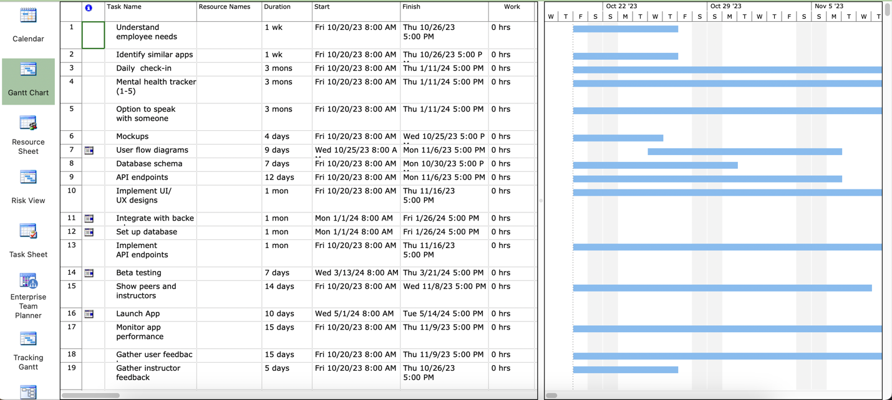

**Detailed Requirements Document**

**\*\*Functional Requirements: \*\***

**1. Check-in – Allows users to check in routinely**

**2. Mental health tracker – To track mental health of patients**

**3. Meeting Rooms – Establish live connections for patients to receive therapy**

**\*\*Nonfunctional Requirements: \*\***

1. **System design – Users can easily interact with the system seamlessly.**
2. **User database – System can efficiently store and retrieve user data.**
3. **Chat rooms - rooms capable of holding up to 10 people.**

**Fully Dressed-Use Cases**

|  |  |  |
| --- | --- | --- |
| Name: Check-in | ID: UC-1 | Priority: High |
| Description: How employees check in | | |
| Actor: employee | Trigger: employee starts system | Type: External |
| Inputs: Outputs:  Employee info -------- employee check in status ------- Mental Health Report file  Current date -------- system | | |
| Flow:   1. System show check in screen. 2. Employee inputs employee info ---------------- Employee number, Name, email, ect... 3. System marks the employee as checked in. 4. System presents options for Survey and Therapy | | |
|  | | |
| Name: Mental Health Survey | ID: UC-2 | Priority: High |
| Description: How Employees take a survey on their mental health | | |
| Actor: employee | Trigger: Employee takes the survey part | Type: External |
| Inputs: Outputs:  Input employee Info------ employee/ system Displays results -------- employee.  Takes survey ------ Employee. survey results ---------- Survey file | | |
| Flow:   1. System gets employee info from UC- 1, or employee. 2. Employee takes the survey by answering the question(s). 3. Employees submit the survey by clicking the submission button. 4. The system displays the results based on employee inputs. 5. Sends survey to Survey file | | |
|  | | |

|  |  |  |
| --- | --- | --- |
| Name: Generate weekly mental health report | ID: UC-3 | Priority: High |
| Description: How mental health report is made | | |
| Actor: Staff | Trigger: It is Friday | Type: Temporal |
| Inputs: Outputs:  Survey Info -------- Survey File Mental health report ------- Mental Health Report file  Current date ------ System | | |
| Flow:   1. Gets/confirms current date. 2. Gets Survey info from the week. 3. Generates report. 4. Output report to Mental health Report file | | |

|  |  |  |
| --- | --- | --- |
| Name: Book Therapy | ID: UC-4 | Priority: High |
| Description: How employees make a Therapy Session | | |
| Actor: employee | Trigger: employee picks therapy option | Type: External |
| Inputs: Outputs:  Desired Therapy Info------employee Therapy Session Info -------- Therapy Session reservation file  Employee info -------- system  Available therapy Sessions ------- Therapy Session reservation file | | |
| Flow:   1. Employee inputs Desired Therapy Info --------------- date and time 2. System checks if date and time is available in therapy session reservation file   2.1. If date and Time is unavailable prompt user to enter new time and date return to step 1.  3. Add therapy session and employee info to Therapy Session reservation file | | |

**Use Case Diagram**

**Research on other systems**

**Virgin Pulse App**:

* Daily mood tracker
* Sleep hour tracker
* “Be kind” tracker (user upload any actions of kindness they performed)
* Exercise tracker
* Daily wellness tips

Design: simple, task bar at top

**Headspace App**

* Therapy sessions within 2 days
* Mental health coaching
* Live workshops
* Critical incident support
* Management consultations and referrals
* Mindfulness, sleep & preventive programs
* Unlimited, on-demand behavioral health coaching
* In-person, phone, or video therapy
* 24/7 phone counseling
* Psychiatry services support for US-based members
* Work-life services including financial, legal, elder care, childcare, identity theft support and more.
* Management consultations and referrals

Design: simple design, task bar at the bottom

**Wellspace App**

* Sleep tracker
* Activity Tracker
* Mental Health Tracker
* Team Challenges
* Content hub

**API Descriptions**

**Login:** Firebase Authentication (by Google) – Using this API, we are granted a more secure login page for users

**Mini games:** Firebase or game center – using this API, we can let the user interact with stress-relieving minigames.

**Meetings: Zoom** – using the zoom API, we can connect users to live meeting rooms